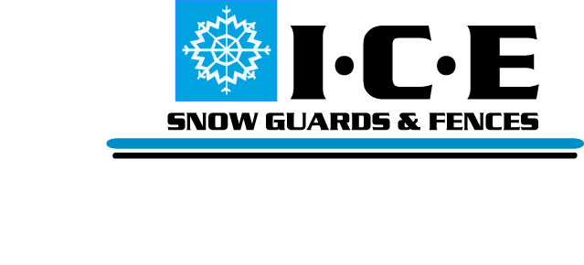
CS7 Snow Guard Specification Sheet
PART 1 GENERAL
  - SUMMARY
- Work Includes
1. Install CS7 Snow Guard to roof system.
2. Provide necessary components: CS7 Snow Guard and Solder.
1.2 RELATED SECTIONS
1. Section 07610 Standing Seam Metal Roofing
2. Section 07410 Preformed Metal Roofing
3. Section 07600 Flashing and Sheet Metal
4. Division 7: Thermal and Moisture Protection
1.3 SYSTEM
- Components
1. CS7 Snow Guard.
2. Solder.
- Design - To be recommended by Manufacturer or Structural Engineer.
1.4 SUBMITTAL - Submit Manufacturers Specifications, recommended layout, product drawings and installation instructions.
1.5 QUALITY ASSURANCE - Installer to be experienced in roofing and snow retention for a minimum of not less than 5 years.
1.6 DELIVERY/STORAGE - Inspect material upon delivery and inform distributer of any damaged or missing items. Protect materials from damage until installation.

PART 2 PRODUCTS
2.1 MANUFACTURER
A. Ice Control Engineering, Inc. - 122 N. 1800 W. Unit #9. Lindon, Utah 84042
Tel. (801) 787-6555; Email: icecontrol@comcast.net; Web: www.icesnowguards.com
2.2 MATERIALS
A. CS7 Snow Guard .065 Copper.
B. Solder.
2.3 FINISH - Mill Finish Copper

PART 3 EXECUTION
3.1 EXAMINATION - Inspect roof structure and panel attachment to insure it will withstand snow loads. Correct all problems before installation of snow guards.
3.2 INSTALLATION - Install according to architects drawing and manufacturer’s instructions.

